Name: Dragan Antic
E-mail: dragan.antic@elfak.ni.ac.rs
Institution: University of Nis
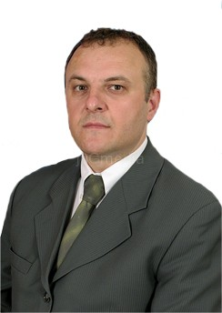 | Dragan Antic, PhD, full professor at the University of Nis, was born in 1963 in Vranje, the Republic of Serbia. He obtained his academic degrees at the Faculty of Electronic Engineering in Niš: BSc in 1987, MSc in 1991, and PhD in 1994. Presently he is employed as Full Professor at the University of Niš, Faculty of Electronic Engineering, Department of Control Systems. During his academic career, he was teaching over fifteen different academic courses on BSc, MSc and PhD degree. He wrote more than 180 scientific papers for journals and conferences, mainly in his areas of interest: modelling of dynamical systems, orthogonal polynomials, sliding mode control, intelligent control, etc.He participated in more than fifteen different domestic and international projects. He is also a member of several professional organizations and an editor or a reviewer in fourteen international journals.
References (max. 5 relevant references)
1. Antic, D., Dankovic, B., Nikolic, S., Milojkovic, M., Jovanovic, Z., 2012. Approximation based on orthogonal and almost orthogonal functions.Journal of the Franklin Institute349(1), 323-336.
2. Peric, S., Antic, D., Pavlovic, V., Nikolic, S., Milojkovic, M., 2013. Ultra selective low-pass linear-phase FIR filter function.Electronics Letters49(9), 595-597.
3. Milojkovic, M., Antic, D., Nikolic, S., Jovanovic, Z., Peric, S., 2013. On a new class of quasi-orthogonal filters.International Journal of Electronics 100(10), 1361-1372.
4. Milojkovic, M., Antic, D., Milovanovic, M., Nikolic, S., Peric, S., Almawlawe, M.,2015. Modeling of dynamic systems using orthogonal endocrine adaptive neuro-fuzzy inference systems.Journal of Dynamic Systems Measurement and Control, DOI: 10.1115/1.4030758.
5. Peric, S., Antic, D., Milovanovic, M., Mitic, D., Milojkovic, M., Nikolic, S., 2016. Quasi-sliding mode control with orthogonal endocrine neural network-based estimator applied in anti-lock braking system. IEEE/ASME Transactions on Mechatronics, DOI: 10.1109/TMECH.2015.2492682.

Project number: 573806-EPP-1-2016-1-RS-EPPKA2-CBHE-JP

"This project has been funded with support from the European Commission. This publication reflects the views only of the author, and the Commission cannot be held responsible for any use which may be made of the information contained therein"

